**OPERATING SYSTEM SERVICES**

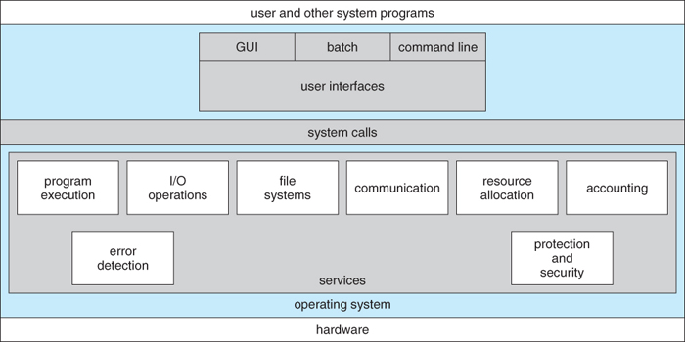

* **User Interface**

Command line interface (CLI): which uses text commands and method for entering them.

Batch: in which commands and directives to control those commands are entered into files and those file are executed.

Graphical user interface (GUI): is a window system with printing device to direct I/O choose from menus and make sections and a keyboard to enter text.

* **Program Execution**

System must be able to load a program into memory and to run that program.

* **I/O Operation**

It involves a file or I/O device. For efficiency and protection, users usually cannot control I/O devices directly. So O.S. must provide a means to do I/O.

* **File System Manipulation**

Read and write files or directories create, delete. Many O.S. provide a variety of file system. Sometimes to allow personal choices, sometimes to provide specific features or performance characteristics.

* **Communication**

Communication may occur between processes that are executing on same computer or between processes that are executing on different computer systems tied together by computer network.

Shared memory Message passing (shared between processors)

* **Error Detection**

Operating System needs to aware of possible errors. Error occur in CPU and memory hardware (such as memory error or power failure) in I/O devices (communication failure on network, or lack of paper in printer).

* **Resource Allocation**

When there are multiple users or multiple jobs running at same time, resources must be allocated to each of them. Many different types of resources managed by operating system.

Example: in determining how best to use CPU, O.S. have CPU scheduling routines that take into account speed of CPU, jobs that must be executed, the number of registers available and other factors. There may also routines to allocate printers, modems, USB device, etc.

* **Accounting**

We want to keep track of which users use how much and what kind of computer resources.

* **Protection and Security**

Protection involves ensuring that all access to system resource is controlled (authentication).

* **System Calls**

System calls provide an interface to services made available by an O.S. These calls are generally available as routines written in C and C++, although certain low level tasks (task where hardware must be accessed directly).